Name: Piyush Patil

Roll no:48

**PROGRAM**

#include <GL/glut.h>

#include <cmath>

#include <iostream>

using namespace std;

float trianglePoints[3][2] = {

{0.0f, 0.5f},

{-0.5f, -0.5f},

{0.5f, -0.5f}

};

float scaleX = 1.0f, scaleY = 1.0f;

float angle = 0.0f;

bool reflectX = false;

float translationX = 0.0f;

void drawTriangle(float points[3][2]) {

glBegin(GL_TRIANGLES);

for (int i = 0; i < 3; i++) {

glVertex2f(points[i][0], points[i][1]);

}

glEnd();

}

void applyTransformations() {

glClear(GL_COLOR_BUFFER_BIT);

glColor3f(1.0f, 0.0f, 0.0f);

glPushMatrix();

glTranslatef(-1.0f, 0.0f, 0.0f);

drawTriangle(trianglePoints);

glPopMatrix();

float transformedTriangle[3][2];

for (int i = 0; i < 3; i++) {

transformedTriangle[i][0] = trianglePoints[i][0] * scaleX;

transformedTriangle[i][1] = trianglePoints[i][1] * scaleY;

}

float tempX, tempY;

float rad = angle * M_PI / 180.0f;

for (int i = 0; i < 3; i++) {

tempX = transformedTriangle[i][0] * cos(rad) - transformedTriangle[i][1] * sin(rad);

tempY = transformedTriangle[i][0] * sin(rad) + transformedTriangle[i][1] * cos(rad);

transformedTriangle[i][0] = tempX;

transformedTriangle[i][1] = tempY;

}

if (reflectX) {

for (int i = 0; i < 3; i++) {

transformedTriangle[i][1] = -transformedTriangle[i][1];

}

}

glColor3f(0.0f, 1.0f, 0.0f);

glPushMatrix();

glTranslatef(translationX, 0.0f, 0.0f);

drawTriangle(transformedTriangle);

glPopMatrix();

glutSwapBuffers();

}

void updateTransformations(unsigned char key, int x, int y) {

switch (key) {

case 's':

scaleX += 0.1f;

scaleY += 0.1f;

break;

case 'r':

angle += 5.0f;

break;

case 't':

translationX += 0.2f;

if (translationX > 2.0f) {

translationX = -2.0f;

}

break;

case 'f':

reflectX = !reflectX;

break;

default:

break;

}

glutPostRedisplay();

}

void init() {

glClearColor(0.0f, 0.0f, 0.0f, 0.0f);

glMatrixMode(GL_PROJECTION);

glLoadIdentity();

gluOrtho2D(-2.0f, 2.0f, -2.0f, 2.0f);

glMatrixMode(GL_MODELVIEW);

}

int main(int argc, char** argv) {

glutInit(&argc, argv);

glutInitDisplayMode(GLUT_DOUBLE | GLUT_RGB);

glutInitWindowSize(800, 600);

glutCreateWindow("Triangle Transformations");

init();

glutDisplayFunc(applyTransformations);

glutKeyboardFunc(updateTransformations);

glutMainLoop();

return 0;

}

Name: Piyush Patil

Roll no:48

**Original**

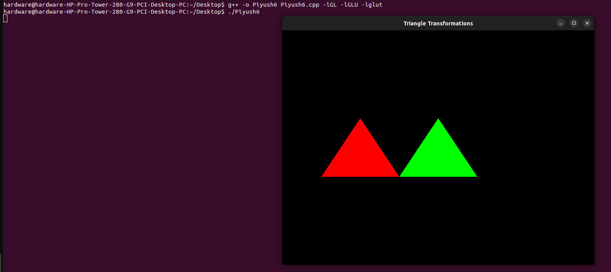

**Translation**

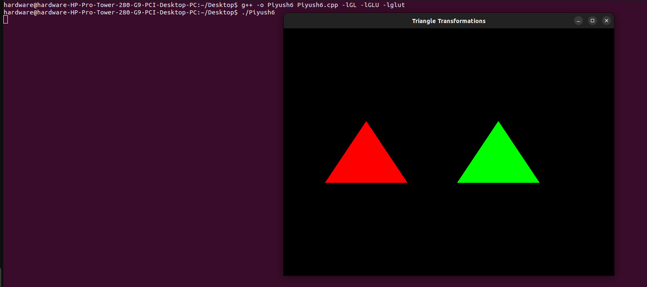

**Scaling**

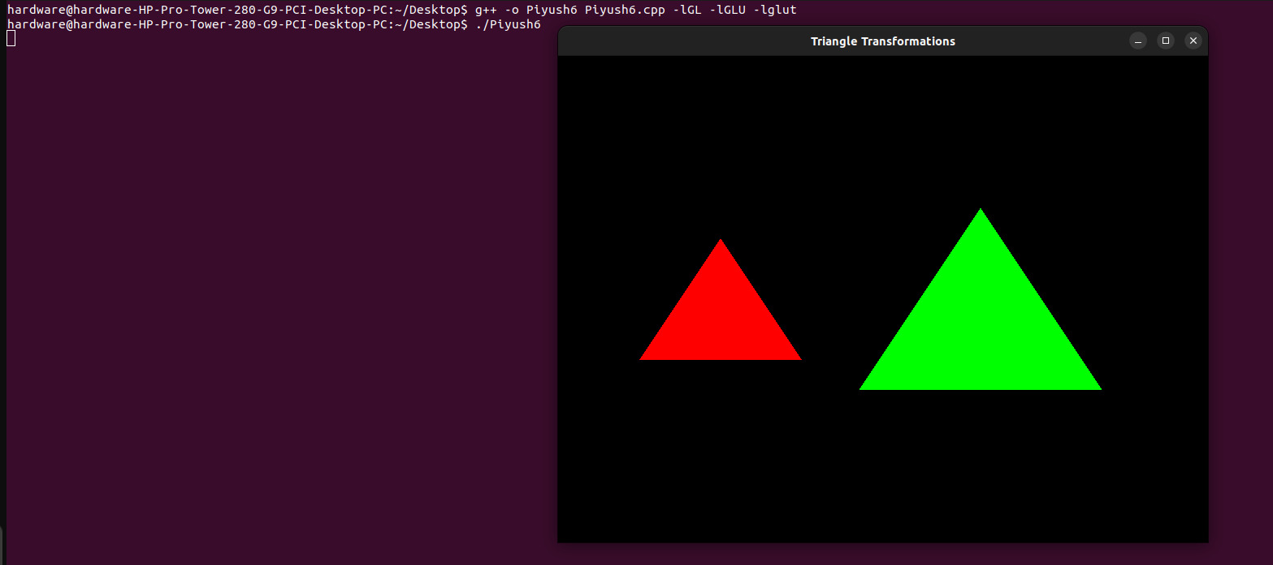

**Rotation**

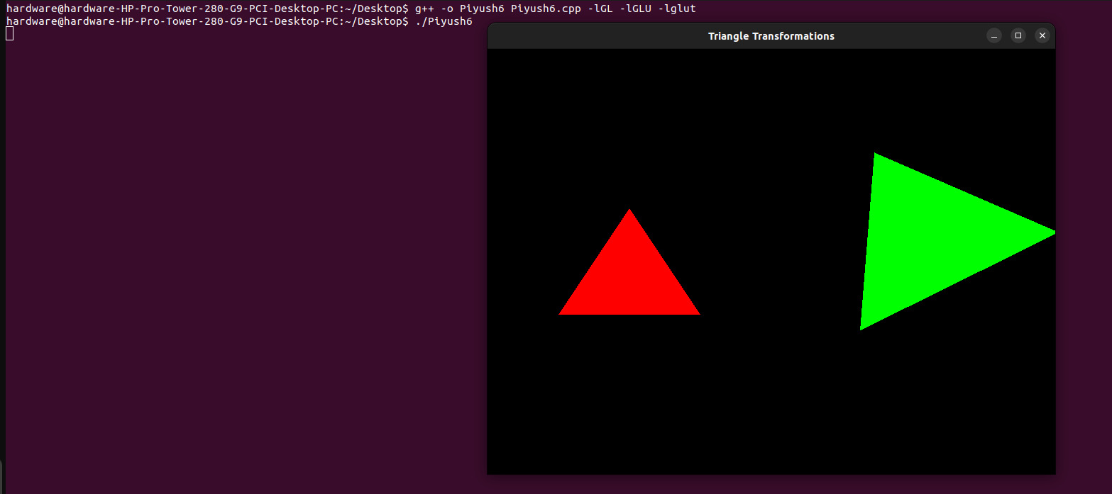

**Reflection**

